**Task 4**

Task IV: Implement stereo rectification and attach the best depth map you are able to generate to the report.

Please find the attached code.

Analysis: How does the subjective quality of the depth maps compare to the ones estimated from Middlebury data? Are there any distinctive problems with some type of content? If (and when) any especially problematic images or sections appear, also include an example of that.

The subjective quality of the depth map is beneath the quality of output shown by the middle bury dataset. A main imperfect rectification problem encountered in stereo matching, is the problem results from the high resolution of stereo images. The reason could also include

* texture less regions,
* occlusion,
* illumination variation,
* the fattening effect,
* discontinuity.

These challenges are effectively solved in recently developed stereo matching algorithms.

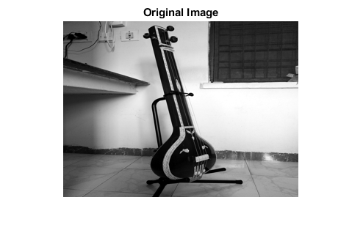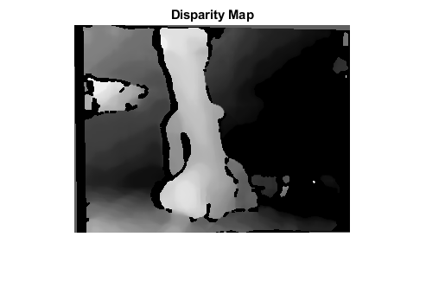

Areas like are texture less regions hence matching stereo pairs are more complex. Block matching along epipolar lines is the core of most stereovision algorithms in geographic information systems. The usual distances between blocks are the sum of squared distances in the block (SSD) or the correlation. Minimizing these distances causes the fattening effect, by which the center of the block inherits the disparity of the more contrasted pixels in the block. This fattening error occurs everywhere in the image, and not just on strong depth discontinuities.

State-of-the-art stereo matching algorithms fail to exactly reconstruct the depth information using stereo images with imperfect rectification, as the imperfectly rectified image problems are not explicitly taken into account.